**SPEECH RECOGNITION SYSTEM**

**CIRCUIT DESIGN:**

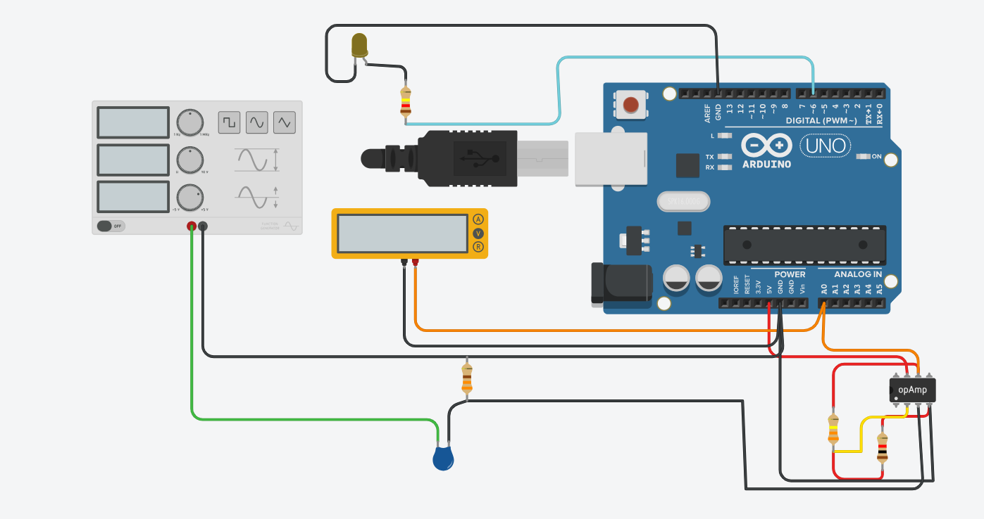

**CODE:**

// averaging bin size, small in simulation

// probably want larger on real hardware

#define BINSIZE 5

// indicator LED pin when threshold met

#define INDIPIN 6

// level of threshold

#define DETTHRESH 500

long a; // instantaneous sample

long arr[BINSIZE]; // averaging bin

long avg; // calculated average

int i; // averaging bin index

int n; // for loop general purpose

int det; // detection active flag

void setup()

{

Serial.begin(9600);

//Serial.println("Setup");

pinMode(INDIPIN, OUTPUT);

digitalWrite(INDIPIN, LOW);

// poulate the averaging bin with the current value

a = analogRead(0);

for (n=0; n<BINSIZE; n++) {

arr[n] = a;

}

i=0;

det = 0;

}

void loop()

{

// stuff values sequentially in bin

a = analogRead(0); // instantaneous value

if (a != 0) { // simulation bug?

arr[i] = a;

if (i > (BINSIZE-1)) { // or ==BINSIZE but don't trust computers :)

i = 0; // go back to start of bin

} else {

i++;

}

// average the values across the bin

avg = arr[0];

for (n=1; n<BINSIZE; n++) { // already have [0]

avg = avg + arr[n];

}

avg = avg / BINSIZE; // average value

// is the level over the detection threshold?

if (det == 0) { // don't care if already on

if (avg >= DETTHRESH) {

det = 1;

digitalWrite(INDIPIN, HIGH);

}

} else if (avg < DETTHRESH) {

det=0;

digitalWrite(INDIPIN, LOW);

}

//debug

//Serial.println("Cur: " + String(a) + ", Avg: " + String(avg));

Serial.println(String(avg));

delay(25); // let the ADC sample

}

}

**WORKING DEMO:**

